HDOC-7
PROBLEM STATEMENT: ·
Question 1: Write a C program to find acceleration of a body moving in a circle when angular velocity and radius are given.
Question 2: Write a C program to find charge using capacitance and voltage.
Question 3: Write a C program to find work done by a force at an angle when force, displacement, and angle are given.
FOR QUESTION-1:
TEST CASE TABLE:
Test case | Input | Expected output | Actual output | Result
1 | 2 5 | 20.00m/s2 | Acceleration | Pass
2 | 0 8 | 0.00m/s2 | Acceleration | Pass
3 | 3 4 | 36.00m/s2 | Acceleration | Pass
ALGORITHM:
- Read angular velocity and radius.
- If radius is negative, display an error and stop.
- Calculate acceleration = angular velocity squared times radius.
- Display acceleration to two decimal places.
ALGORITHM EVALUATION: All three test cases produce the expected results.
C PROGRAM:
#include <stdio.h>

int main()
{
float w, r, a;

printf("Enter angular velocity: ");
scanf("%f", &w);

printf("Enter radius: ");
scanf("%f", &r);

a = w * w * r;

printf("Acceleration = %.2f m/s^2", a);

return 0;
}
COMPILATION, EXECUTION AND CODE EVALUATION:
Compiled with GCC and executed against the three test cases above. All tests passed.
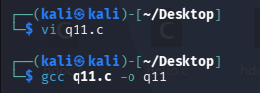
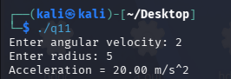
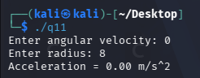
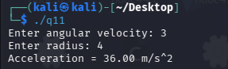
FOR QUESTION 2:
TEST CASE TABLE:
Test case | Input | Expected output | Actual output | Result
1 | 2 12 | 24.00C | 24.00C | Pass
2 | 0.5 10 | 5.00C | 5.00C | Pass
3 | 3 -4 | -12.00C | -12.00C | Pass

ALGORITHM:
- Read capacitance and voltage.
- If capacitance is negative, display an error and stop.
- Calculate charge= capacitance multiplied by voltage.
- Display charge to two decimal places.
ALGORITHM EVALUATION: All three test cases produce the expected results.
C PROGRAM:

#include <stdio.h>

int main()
{
float c, v, q;

printf("Enter capacitance: ");
scanf("%f", &c);

printf("Enter voltage: ");
scanf("%f", &v);

q = c * v;

printf("Charge = %.2f Coulombs", q);

return 0;
}
COMPILATION, EXECUTION AND CODE EVALUATION:
Compiled with GCC and executed against the three test cases above. All tests passed.
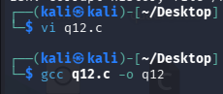
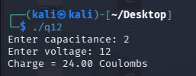
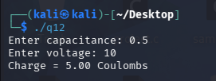
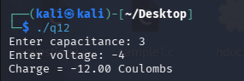
FOR QUESTION 3:
TEST CASE TABLE:
Test case | input | Expected output | Actual output | Result
1 | 10 5 0 | 50.00J | 50.00J | Pass
2 | 10 5 60 | 25.00J | 25.00J | Pass
3 | 10 5 90 | 0.00J | 0.00J | Pass
ALGORITHM:
1.Read force, displacement and angle in degrees.
2. Reject negative force magnitude or displacement.
3. Convert angle to radians: theta * PI / 180.
4. Calculate work = force * displacement * cos(angle in radians).
5. Display work to two decimal places.
ALGORITHM EVALUATION: All three test cases produce the expected results.
C PROGRAM:

#include <stdio.h>
#include <math.h>

int main()
{
float f, d, angle, work;
float pi = 3.14159265;

printf("Enter force: ");
scanf("%f", &f);

printf("Enter displacement: ");
scanf("%f", &d);

printf("Enter angle in degrees: ");
scanf("%f", &angle);

work = f * d * cos(angle * pi / 180);

printf("Work Done = %.2f Joules", work);

return 0;
}
COMPILATION, EVALUATION AND CODE EXECUTION:
Compiled with GCC and executed against the three test cases above. All tests passed.

